Дата: 19.02.2025

Клас: 7-Б

Предмет: англійська мова

Тема: Діагностувальна контрольна робота за модулем 5 «Eating habits».

Мета: : формувати навички вживання лексичних одиниць по темі; удосконалювати навички читання, аудіювання й усного монологічного мовлення; розвивати пізнавальні інтереси учнів; виховувати інтерес до самостійного пошуку потрібної інформації, а також загальну культуру учнів.

Вчитель: Руда Д.В.

Хід уроку

1.Greeting

Good afternoon, guys! I’m tickled pink to see you. Are you ready to start our lesson? All set?

Let`s get down to business.

2. Wаrm up / Listening

Уважно слухати аудіо трек і дати відповідь на питання вчителя <https://www.youtube.com/watch?v=rZs-joM2Sl4> .

3. Speaking

Дати усно відповіді на питання :

Do lots of people eat junk food in your country?

Does your government educate people about the dangers of junk food?

Do you think junk food makers are immoral and should think more about people’s [health](https://esldiscussions.com/j/junk_food.html)?

What do you think of people who eat mostly junk food?

Does junk food or good quality healthy food make you happier?

If you had to choose between a strict vegetarian diet forever or a junk food diet forever, which would you choose?

Why does junk food cost so much?

What is the definition of junk food?

Is chocolate the most addictive junk food?

Do you think people ate junk food hundreds of years ago?

4. Повторення

<https://wordwall.net/uk/resource/12802241/healthy-eating>

<https://wordwall.net/uk/resource/9491122/eating>

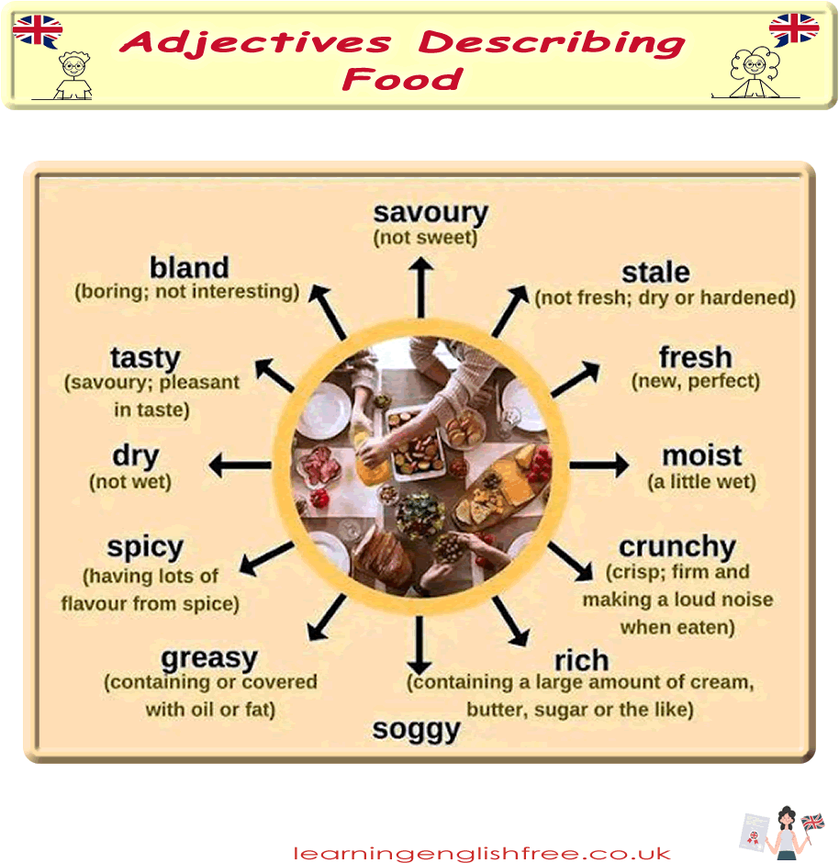

Словник :

*A slice of-шматок..*

*A can of-банка..*

*Allergic-алергічний(ельоджік)*

*Appetizer-закуска(апетайзер)*

*Main course-основана страва( мейн корс)*

*Whipped cream-вершки(віпд крім)*

*Flavour – смак (флейвьо)*

*sweet / sugary – солодкий(шюгері)*

*savoury – не солодкий (сівері)*

*salty – солоний*

*sour – sweet and sour sauce*

*spicy – пряний*

*bland(бленд) / plain(плейн) (not much flavour) – звичайна, проста на смак plain-tasting food / Boiled rice tastes very bland; not having a [strong](https://dictionary.cambridge.org/ru/%D1%81%D0%BB%D0%BE%D0%B2%D0%B0%D1%80%D1%8C/%D0%B0%D0%BD%D0%B3%D0%BB%D0%B8%D0%B9%D1%81%D0%BA%D0%B8%D0%B9/strong" \o "strong) [taste](https://dictionary.cambridge.org/ru/%D1%81%D0%BB%D0%BE%D0%B2%D0%B0%D1%80%D1%8C/%D0%B0%D0%BD%D0%B3%D0%BB%D0%B8%D0%B9%D1%81%D0%BA%D0%B8%D0%B9/taste" \o "taste)*

*bitter (бітер)– гіркий Coffee tastes bitter without sugar.*

*greasy / fatty (грісі) – жирний foods like chips and hamburgers can be greasy*

*moist / juicy (мойст) – соковитий a juicy mango*

*dry(драй) –сухий  toast tastes too dry without butter*

*lumpy (лампі) – lumpy porridge (з комками,грудкою)*

.

*Lettuce –салат (летіс)*

*Grapes-виноград (грейпс)*

*Spinach-шпинат(спінеч)*

*Cereal-каші (зернові) (сіріал)*

*Beans-боби (бінс)*

*Dairy products-молочні продукти (дейрі продактс)*

*A bar of-плитка (е бар аф)*

*A bottle of-пляшка (е ботл аф)*

*A bowl of-миска(е боул аф)*

5. Writing

Виконати вправу подану нижче. (повторення past perfect)

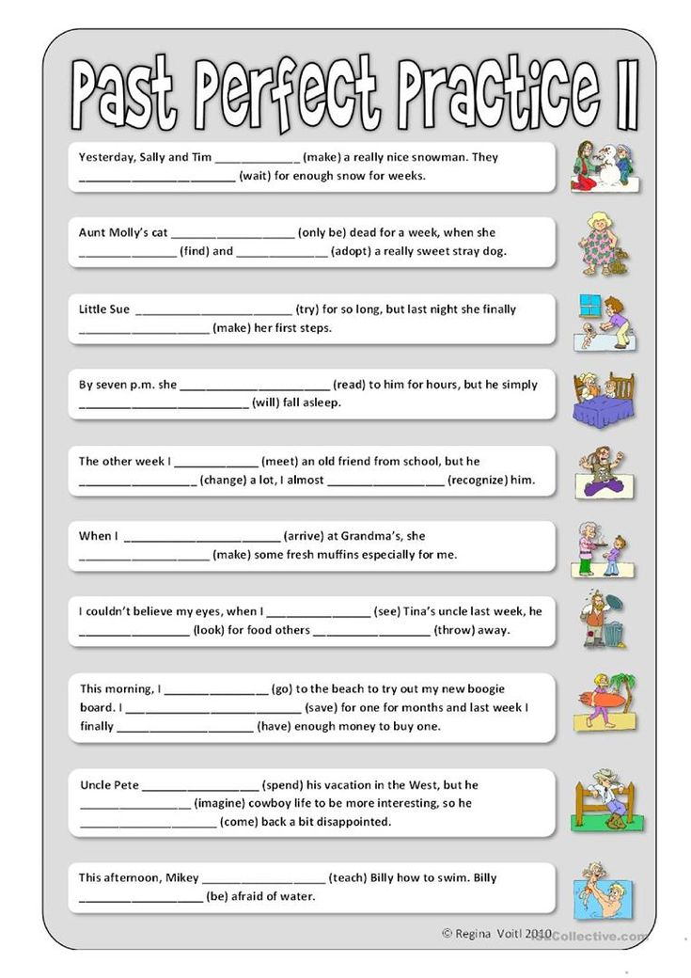

6. Homework

1. Виконати контрольну роботу подану нижче.

**Full Blast 7 Name_________**

**Surname_________________**

**Date:**_____________________________________________________________________

**Module 5. Eating habits**

**Test**

**Variant 2**

1. **Vocabulary** - 3 points

**Complete the phrases with the words in the box, translate into Ukrainian**

*a can a bottle a slice a glass*

1. **_______** of corn - ________________
2. _______ of cheese- ______________
3. __________ of strawberry juice - ___________________
4. stir the mixture -________________
5. saucepan - ___________________
6. boil the water - _________________

**II.Grammar** - 3 points

**1.Choose a, b or c**

1. Can you add … salt to my soup please.
2. much **b)** a few **c)** a little

2) We went to the supermarket to find … present for my dad.

1. another **b)** other **c)** the others

3) I’ ve got … duties about the house.

**a)** too much **b)** too many **c)** a few

**2. Circle the correct words.**

1. A: I think there’s **anyone / someone** downstairs.

B: I can't hear **something / anything**.

1. A: Are there **any / some** lemons in the fridge?

B: No, there aren’t **any / no**. We need to go to the supermarket.

3**. Fill in Past Simple or Past Perfect.**

1. They_________ (drink) a cup of tea after they__________

(finish) lunch.

1. They ______ (go) for a sightseeing tour after the bus _______ (arrive).
2. Before they ______ (move) to Liverpool, they _________ (sell) everything.

**III. Listening- 1,5 points**

Listen to a couple ordering food at a restaurant and answer the questions.(**a|b**)

<https://test-english.com/listening/a1/ordering-at-the-restaurant-a1-listening-test/>

1. The woman orders chicken and rice for her main course.

**a.**True **b.**False

1. The woman orders wine and the man orders beer.

**a**.True **b.**False

1. The woman chooses white chocolate cake for dessert.

**a.**True **b**.False

**IV. Reading** - 1,5 points

Read the text and write **True** or **False**.

**Healthy living** with Susan Miller

Welcome to my blog! As you know I really enjoy eating delicious meals. When I was younger I used to cook with lots of olive oil and butter because I wanted my food to be tasty. I used to believe that healthy food meant tasteless food. But today I know better.

One healthy dish that has become my favorite is a chicken salad. This colorful dish gives our body all the necessary vitamins and proteins and tastes amazing too.

The secret of the perfect chicken salad is in its ingredients. So make sure you use only the freshest ones. You can use other kinds of meat instead of chicken, but I prefer it because it goes well with vegetables. I like to put lots of lettuce, tomatoes, cucumbers, an onion and pepper. Then I grate some cheese and mix it in too.

Finally, I add a tablespoon of olive oil and pour some fresh lemon juice on top. Try this salad. You are going to have it.

1)________ Susan thinks that healthy food equals tasteless food.

2) ________ The Secret of the perfect chicken salad is in roasted chicken.

3)________ Susan adds a tablespoon of mayonnaise on top.

**V. Writing and speaking** - 3 points( choose one of the tasks)

**Answer the following questions** then speak. / Imagine your friend will hopefully invite you to get together at the restaurant on his birthday next Wednesday. But you can't make it. Write that you had to **refuse the invitation.**

● *What's your favorite food?*

*● What do you usually eat in a day?*

*● How often do you buy junk food? What is it?(give examples)*

*● Do you have a healthy diet? What should you do to have healthy nutrition?*

______________________________________________________________________________________________________________________________________________________________________________________________________________________________________________________________________________________________________________________________________________________________________________________________________________________________________________________________________________________________________________________________